**Initial Project Description**

**Team Name**

Team5

**Team Members and Email Addresses**

Dylan Klohr | [dylan.cs.ku@gmail.com](mailto:dylan.cs.ku@gmail.com)

Gabe Magnuson | [g400m001@ku.edu](mailto:g400m001@ku.edu)

Philip Wood | [p3wood719@gmail.com](mailto:p3wood719@gmail.com)

John Ward | johnw.mkv@gmail.com

Joe Werle | werlej@hotmail.com

Alan Wang | [ultimate801@gmail.com](mailto:ultimate801@gmail.com)

**Meeting Times**

9/23 @ 11:00am

10/14 @ 11:00am

11/21 @ 11:00am

**Lab Meeting Time**

4:00pm Monday

**Group Contact**

Dylan Klohr

**Project Sponsor**

None

**Project Description:**

For our capstone project, we have decided to develop a location-based mobile platform. It’s our hope, that said platform can be used to automate existing proximity-based actions and workflows (e.g., class attendance, information distribution, etc.). For example, a professor teaching a class in a large lecture hall such as Budig 120 who wishes to conduct daily-attendance currently faces several challenges without a modern technological platform to assist them. Currently, methods commonly leveraged for attendance in such a setting include all students signing in on a communal sign-in sheet, requiring either the professor or a TA to actually record said sign-ins manually. In addition to the time required to both pass the sign-in sheet and record its contents later, the additional challenge of authentication comes into play. In the current schema for classroom-attendance, there is very-little that prevents one student from signing both himself or herself in as well as other students not actually present in the class. This project is motivated by the desire to optimize common actions that have existed for decades and bring them into the 21st century by taking advantage of modern advancements and insights in the realm of technology. Our platform would combat the aforementioned problems in that it would allow a customizable system for individuals to connect with others near-by and collect desired information from them, as well as provide natural authentication of who is actually “checking in.” Upon the completion of our capstone project, we aim to provide a mobile utility platform aimed at providing new functionalities to a given population in a close-proximity to one another.

**Project Milestones**

First Semester:

* Finalize project scope and desired features (Wednesday, October 12)
* Project Proposal Video Completion (Monday, October 24)
* Project Structural Design Completed (End of semester)
* Research:
  + Helpful third-party utilities identified
* Documentation
  + Class Diagrams
  + Domain Model
  + Use-Case Diagram

Second Semester:

* Database implementation / Database API / Android UI (Friday, February 24)
* Ability to create a group and collect users’ locations (Friday March, 31)
* Additional functionalities added to application (Friday, April 21)
* Attendance
  + Admin custom posts
* Usability and Unit testing completed (Friday, May 5)

**Gantt%20Chart.pdf**

**Project Budget1**

No Budget for this project

**Work plan (current)2**

Dylan Klohr:

* UI / UX design and implementation
* Front-end

Gabe Magnuson:

* Database Implementation

Philip Wood:

* Map Overlays/Displays and location pinging

John Ward:

* User Authentication
* UI Implementation
* Front-end

Joe Werle:

* Admin Capabilities

Alan Wang:

* Group Creation/Settings
* Front-end

**Github link**

* <https://github.com/dylanCSKU/eecs_capstone.git>
  + Contact Dylan Klohr for access to private repo

**Preliminary Project Design**

Over the years, social media has redefined how we interact across the web and in person. As a general tool, they serve their purpose in providing a convenient media for a broad spectrum of interaction. That being said, we feel that particular features that facilitate group interaction, in the real world, are lacking. Specifically, we are looking to provide a flexible mobile solution that allows individuals within a group to check-in and interact with group leaders based on proximity to a specific location. While current solutions allow for location based check-in, they tend to be bound to a specific event or location, as opposed to a proximity of a central moderator or re-definable location. Because of this, we feel that implementing our proposed-solution will allow our users to better adapt and interact with others, given their active lifestyles.

The idea for our solution grew out of the desire to streamline group interaction in the classroom and during sports events. We feel as that the archaic method of passing a piece of paper around and having group members physically sign-in was not only extremely time consuming, but often yielded unreliable results as there exists no automated identity-check. Consequently, there is nothing stopping group members for signing in under another group member’s name. Furthermore, we wish to improve the KU Basketball Camping experience by implementing a one-click instant check-in process that can be initiated at any time by a group moderator. The issue with camping is that anyone can ask to call “roll” (see kubasketballcamping.com for more details) at any time. If a group isn’t present at roll call, they lose their current spot in line. At the moment, camping staff need to call each group one at a time and manually determine if they are to be considered “present.” Our app would allow all groups to instantly check-in based on their location, thus ensuring a group member’s identity and location. We believe this change would not only speed up the process of “roll call,” but improve the overall camping experience.

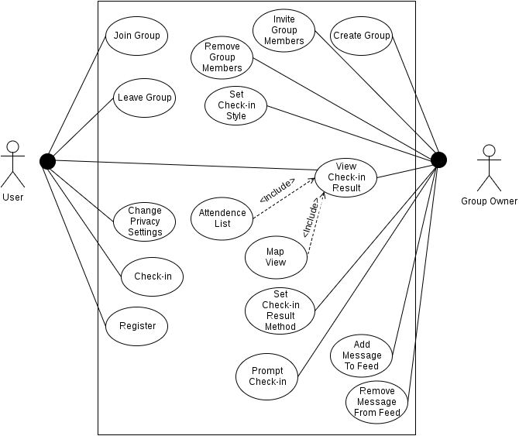

Stemming from those two specific use-cases, we feel that the versatility our app brings to the market allows for a multitude of real life applications. Because users are no longer confined to check their location relative to a static location, it becomes easier for on-the-go groups to perform check-ins with their leader. From group exercise sessions to school field trips; group leaders, moderators, and chaperones would now possess the ability to easily message, and ping, the location of members in their group. This ensures that all group members are on the same page, and provides moderators with peace-of-mind. Below, a mockup of a potential “landing page” that may one day resemble the screen users are greeted with has been included in an effort to demonstrate what it is that we wish to create.

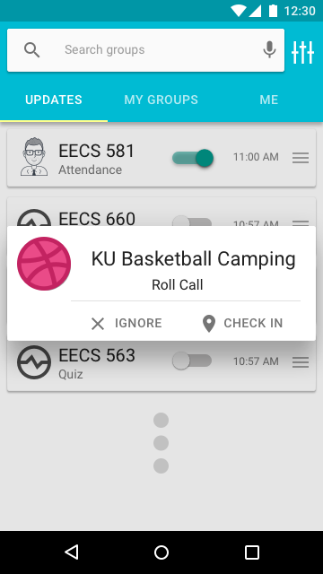

***Implementation of Features:***

*Location Check-In:*

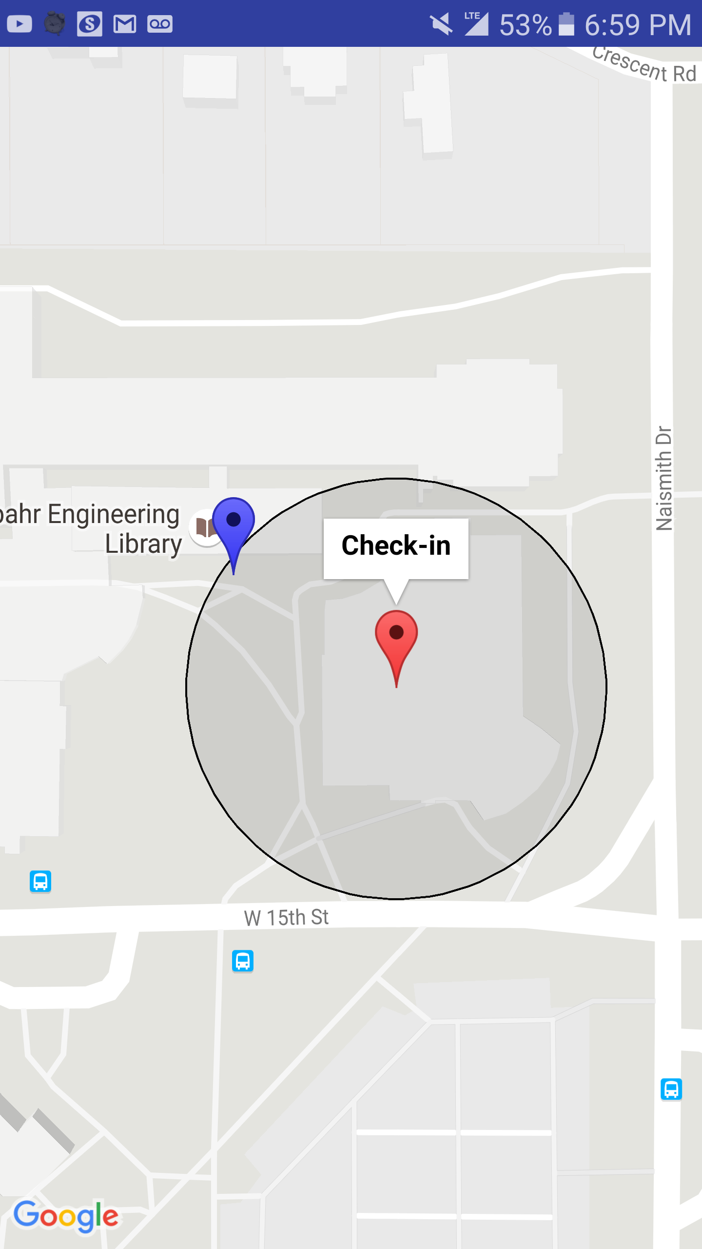

Conveniently, Google Play Services provides a free Google Maps API for displaying locations with overlays on a map, and FusedLocationAPI for acquiring users’ current location. Something to note is the requirement surrounding permissions on Android devices. As of Android 6.0, permissions are required to be run at runtime, meaning that anytime we want to use a service that requires permissions (ie. location services), we must check that permissions are granted, and if they aren’t granted then prompt the user for access. In terms of check-in, when the moderator begins a check-in, their location will be acquired using FusedLocationAPI and sent to the server. A notification will then be sent, using a standard notification process, to members of the group prompting them to check-in. Once they acknowledge the request, given that they have already provided location permissions, the app will check the proximity of the user to the moderator’s location, or defined location, and consider them checked-in if they are presently within a moderator-specified distance of the aforementioned moderator or defined location.

*Group Locate:*

For situations in which a group may be spread-out within a given area, we will provide moderators the ability to check member locations on a map. This would be ideal for a vacation to an amusement park or field trip to a museum where chaperones may not always have line-of-sight contact with group members. Put simply, they would always have peace of mind with our one-touch Group Locate feature. Specifically, mapping and overlays are done within the Google Maps API.

We acknowledge that allowing moderators to display member location within an area is potentially a security risk. As such we will provide users with flexible settings to allow them only to be located during specific times, set by each individual user.

*Group Creation and Management:*

As a whole the core of our app comes down to the interactions between moderators and members of a group. As such we would like to provide a simple registration and login system, allowing users to login specifically to our app using an email, or though popular social media sites (Facebook, Twitter, Google Plus). All three social media sites provide API’s for identity validation, and login procedures. A nice consequence of using these services is the fact that, to the best extent possible, we can check the identity of our users. While not foolproof, we are able to cut down on the number of false check-ins.

Most of the work for group creation and management will likely need to be created from the ground up. For starters, we will allow moderators to send group invitations to users, either through the app itself, or through email, since an email will be used in the login process regardless of method. Our application will provide moderators with a one-way chat function, allowing them to send important messages to the group. Additionally, while moderators are the only individuals who are able to begin a check-in we will allow user to alert the moderators that they would like to begin a check-in. This specifically addresses the basketball camping issue, since it allows camping groups to easily request roll call at any time, and it allows the moderator to initiate an automated roll call quickly in response.

*Storage:*

We will store all of our information on a MySQL database which is run off our EECS account.

**Intellectual Property and Ethical Issues**

Intellectual property issues began to crop up more and more as we delved deeper into our project. The nature of our project being a location based Android application has us borrowing a lot of work from others in the form of API's and open source projects. It will be important as more third-party-leveraging functionality is added that we follow any requirements that come along with their licensing. Additionally, though not strictly a legal issue, it is important to us that our application does not come off as a copy of other applications that use Google location and map services such as Google Latitude. This will include paying particular attention to similar or competing applications to make sure this project is offering something distinct.

Because a lot of the work done by our app will be done on the back end, the question of boundaries that we may overstep ethically while making this app comes into play. A large ethical issue that we face is privacy as it relates to location based services. Google already provides a location service that periodically calculates a devices location, and Android (6+) requires any app that tries to use this service to get permissions from the user before hand (at installation), however, our application will be saving and sharing locations between phones and the ability to let others see your location is a central moral concern. Throughout development we plan to answer this by implementing a design that balances simplicity while ensuring the user always has control over what is happening with his or her location. We will likely have to implement settings that the user can control exactly how freely we will be using their location with regards to how visible they appear to other users of the app. Due to our back end including both location and account information, it is additionally important that we not only make sure the user has control of their privacy but also that we securely store this sensitive information in a manner that is less-susceptible to malicious attack.

**Change Log**

Note: All changes to this contents of this document after we submitted our initial project description are denoted with a superscript at the end of the header with content that has been changed.

[1] *Project Budget*: We no longer need to purchase domain name, web-hosting, database hosting, as we are planning to use the EECS free options.

[2] *Work Plan:* Tasks and division of labor further identified and extrapolated.